EXPERIMENT-4
AIM:
To perform Histogram Equalization on a grayscale image using OpenCV in Python and compare it with the original image.
Program:
import cv2
image = cv2.imread(r"C:\Users\sivad\OneDrive\Desktop\Computer Vision\sample(1).jpg.png")
if image is None:
print("Error: Image not found!")
exit()
gray_image = cv2.cvtColor(image, cv2.COLOR_BGR2GRAY)
equalized_image = cv2.equalizeHist(gray_image)
cv2.imwrite(r"C:\Users\sivad\OneDrive\Desktop\Computer Vision\equalized_output.jpg", equalized_image)
cv2.imshow("Original Grayscale Image", gray_image)
cv2.imshow("Histogram Equalized Image", equalized_image)
cv2.waitKey(0)
cv2.destroyAllWindows()
Input:
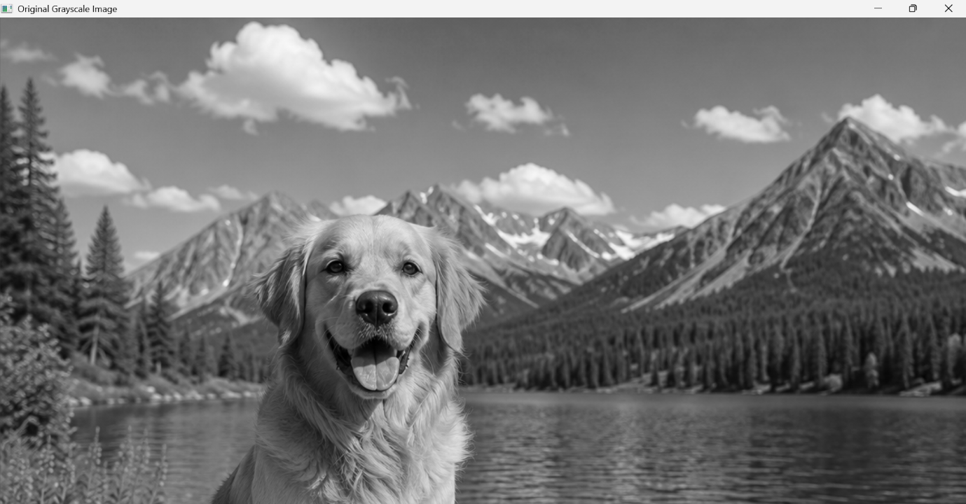

Output:
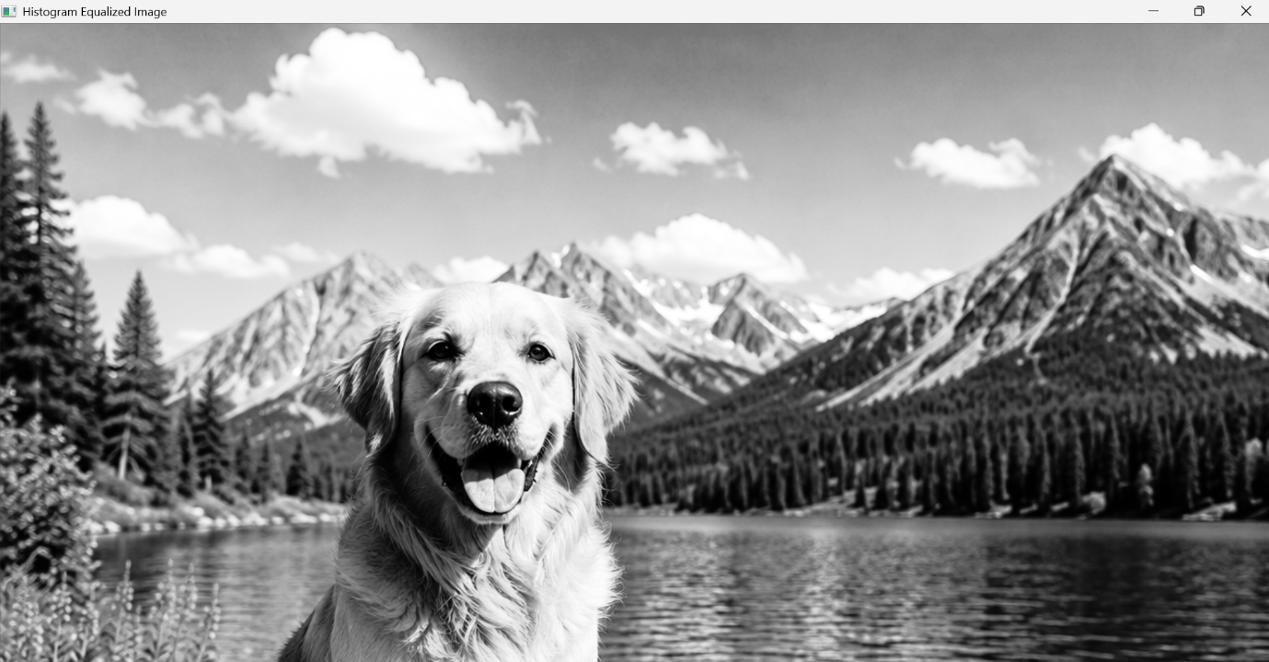

Result:
Successfully performed Histogram Equalization on the input image and compared the equalized image with the original grayscale image using OpenCV in Python.

